TaxSlayer 2016 Tips v3a

TaxSlayer handles most, but not every, situation required to prepare a correct tax return properly. Prior tips have been incorporated into the NTTC Modified Pub 4012 v4. The tips below are not in the NTTC Modified Pub 4012 v4. As TaxSlayer continues to evolve, some of these tips may change. Changes to this document from the previous version are flagged with a vertical line in the left margin.
Please let the National Tax Training Committee know through a OneSupport Request ticket if you have identified additional tips or have other suggestions.

Income
- Medicaid waiver payment on W-2 – Refer to NTTC-modified P 4012 page D-45 for federal information. Removing the excluded wages from state calculations may be possible by entering -0- in state wages on the W-2 (to be confirmed state-by-state).
- Sale of main home – The TaxSlayer sale of main home worksheet may not include the transaction on Form 8949 if it is a nondeductible loss (even though Form 1099-S has been received and we must report it). And, it does not show the “E” code for selling expenses. Until fixed, counselors should not use the worksheet. Instead, enter the transaction as you would other capital gain or loss transactions and use the appropriate codes. If using more than one code, net the adjustment amounts.

Deductions/Credits
- Schedule A sales tax deductions – You can use the General Sales Tax Deduction Income Worksheet in the NTTC-revised Pub 4012 or the Sales Tax Worksheet at http://cotaxaide.org/tools/ to compute total income for the sales tax tables. If using the TaxSlayer calculator, use 366 days (not 365) for 2016. Note – do not use the TaxSlayer calculation if there is an IRA rollover as it reportedly incorrectly includes that distribution in the total income.
- Tax credits for unclaimed dependent (education and retirement savings) – An unclaimed dependent cannot claim their own exemption deduction, but they are allowed credits for education (AOC or LLC) and retirement savings. TaxSlayer will not allow either credit and there is no way to manually fix this. Advise the taxpayer to go to a paid preparer (or to come back later in the season to see if TaxSlayer has fixed it).

Other
- Dependent not living with taxpayer – For example a sibling or parent, use “other reasons” in the drop down menu for months lived in home.
- ACA
  - Executive order Jan 20, 2017 – The executive order does not affect how Tax-Aide will prepare 2016 tax returns. We need to wait for Congress or Treasury to change the law or regulations. Counselors can remind taxpayers subject to a shared responsibility payment of the option to petition the marketplace for a hardship exemption; but, it remains the taxpayer’s decision.
  - Looking up 2016 quotes – State exchanges may not have 2016 and prior year quotes available for exemption purposes. HealthPocket.com may be able to provide the needed quote information. Use this site with caution – it may quote one individual at a time. If so, add up the by-individual quotes to get the total LCBP or SLCSP needed to complete the Bogart Affordability Calculator.
  - SLCSP for 2016 PTC – If your state exchange does not have quotes online for PTC purposes, we suggest you first try your state exchange to get the needed SLCSP quote. If unsuccessful, use HealthPocket.com or other resource you find useful. If the state’s rates have not changed much, it may be necessary to use a later year’s plan quotes – but this should be a last choice.
  - Required to repay all EXCESS APTC? – All APTC must be repaid without a cap if income is greater than 400% of FPL and for the two rare situations described below.
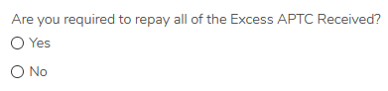
TaxSlayer handles the 400%-or-more FPL situations well and you don’t need to answer this question “yes.”
CAUTION: TaxSlayer may default the answer to “yes” – make sure to change it to “no” unless either of the following applies.
The very rare situation when this box should be checked “yes,” is when the system would otherwise apply the cap to the repayment and the taxpayer must really repay all the APTC (not just the excess). There are just two very rare situations where this might arise:
    - A person who is not lawfully present in the U.S. but got a marketplace policy with APTC (but be careful if the policy also covers a person who is eligible for PTC as PTC is allowed for them*).
    - Specific Health Care Tax Credit (HCTC) situations – see Form 8962 instructions. Note: HCTC is out of scope for Tax-Aide.
In these two very rare situations where NO PTC is allowed, check the box yes AND do not enter the plan premium (column A on 1095-A). If you enter the column A premium and a SLCSP, TaxSlayer will allow the computed PTC and show the rest as excess without a cap – that would be the wrong answer. In these very rare situations, 100% of the APTC must be repaid. By not entering the column A premium, the computed PTC is zero and all APTC is excess.
* This situation is also very rare, e.g., unlawfully present taxpayer gets coverage with APTC for lawful children. If the policy also covered the unlawful person, it becomes very complex as highlighted in Pub 974. To compute the correct allowable PTC, the plan premium (column A on 1095-A) and SLCSP amounts would have to be for the eligible persons on the return only. Your Local Coordinator may decide that these situations are too complex and should be referred to a paid preparer.
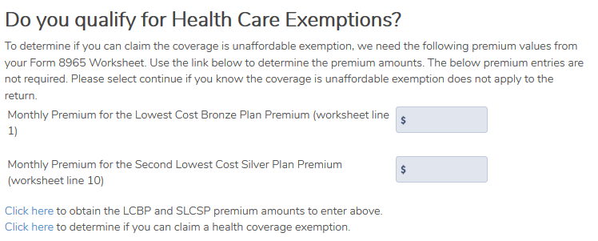
  - Affordability exemption – TaxSlayer continues to work on its affordability exemption worksheet. However, it does not ask for the amount of any premium that is paid through a salary reduction arrangement (pre-tax medical) which affects the affordability threshold. Also, there could be an employer offer or circumstances might change during the year. Therefore, the result is not reliable. Simply “continue” past this page.
Continue to use the Bogart Affordability Calculator at http://cotaxaide.org/tools/ and select the affordability exemption in TaxSlayer for the person(s) to whom it applies.
  - New unaffordable coverage exemption question – It is unclear how this question works in TaxSlayer, if at all. The answer does not appear to affect the return (so answer it yes and adjust if necessary with the next screen).
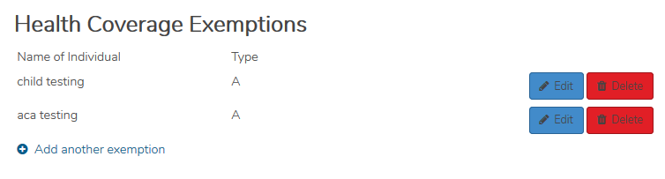
The next screen implies that the A exemption has been applied, but it has not. You need to edit each person on the return and select the appropriate exemption and months, if any.
  - Gross income filing threshold exemption – TaxSlayer cannot properly compute gross income on the return when there are grouped capital transaction gains and losses that have been netted out. If the gross income filing threshold exemption (8965 Line 7) might apply, do not group the capital transactions. This way, TaxSlayer will be able to properly compute gross income on the return.
Note: TaxSlayer properly adjusts gross income for expenses on Schedule C.
- Signature for deceased taxpayer – Please refer to page K-23 of the NTTC-modified Pub 4012 regarding a taxpayer that dies after the tax year end. It’s possible that the IRS might reject the return. If so, you may need to paper file the returns or delay the filing. TaxSlayer is aware of the issue and working to remedy the situation.
- Form 1040-A or Form 1040-EZ – Although you can select Form 1040 in the print package so that it is the form printed, it merely prints the long form. It does not change the form that is transmitted (-A or -EZ will be transmitted). To force a long Form 1040 for both printing and e-file purposes, add $1 to Other Income captioned “To force Form 1040” and then add a negative $1 to Other Income captioned “To force Form 1040 offset.”
- Form 8888 – Unless your site has a great need for this form, we suggest to not activate it as it removes the dual input requirement for routing and account numbers. With the Form 8888, it asks for the numbers once only; without Form 8888, you’ll see the dual input screen. Each site should determine whether to use Form 8888 or the dual input screen.
- Print sets – Please be sure the taxpayer’s printed copy of the return is complete. You may wish to compare the “preview return” forms with the printed copy of the return. Forms 8949, 8962, 8965 and others were recently made available. They need to be added to your custom print sets.
You may need to print additional forms or pages that are not in any print set, especially for state forms. If so and not already done, please submit these issues through your state’s point of contact or to TaxSlayer directly at support@vita.taxslayer.com. Note that worksheets are not transmitted and may be selectively printed for the taxpayer’s records.
Very important: do not print or include the due federal diligence forms for the taxpayer’s copy. Although we have to answer the questions to process the return, the forms are NOT transmitted and are not a part of the Tax-Aide-prepared return. The status of state due diligence forms, if any, should be determined at the state level.
- Direct debit – Counselors need to highlight scheduled direct debits for the taxpayer on the document envelope or otherwise. The print sets do not include an ACH form or reminder page at his time.
- No Refund/Balance Due Return – Select “Mail Payment” as the Federal Return Type to e-file a return that has no refund or no payment due.
- Zero AGI returns – To deter identity theft and e-file the return, Tax-Aide recommends that a return be e-filed, even though not required. Add $1 to other income and describe as “TO ENABLE E-FILE.”

General Note: As TaxSlayer continues to evolve, we will see more things start to work in a good way. We may also find additional issues. This places greater emphasis on a thorough quality review to make sure the final return is as accurate as possible.
Please know that your dedication and efforts are greatly appreciated!

